Assessment Schedule – 2012
Mathematics and Statistics: Apply calculus methods in solving problems (91262)
Evidence Statement
Q | Evidence |  | Achievement (u) |  |  | Merit (r) |  |  | Excellence (t)
 |  |  | Apply calculus methods in solving problems. |  |  | Apply calculus methods, using relational thinking, in solving problems. |  |  | Apply calculus methods, using extended abstract thinking, in solving problems.
ONE  (a) | f ' (x) = 6x² – 10  f ' (2) = 14 |  | Correct.
(b) | 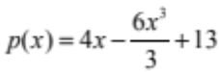  or  p(x) = 4x – 2x³ + 13 |  | Correct.
(c) | v = 0.2 t + 5  When v = 8  8 = 0.2t + 5  t = 15 secs |  | Finding expression for v  and equating to 8. |  |  | Finding the value of t.
(d) | 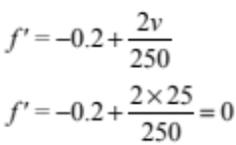  So v = 25   turning point  Shape of parabola or  f " > 0 minimum |  | Finding expression for f ′. |  |  | Substitute 25 for v and show the value of the expression is 0  or find v = 25  from f ′ = 0 |  |  | Justification.
(e) | 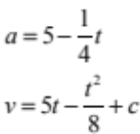  t = 0, v = 0  c = 0  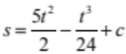  t = 0, s = 0 c = 0  When t = 30  s = 1125 metres |  | Finding expression for v. |  |  | Finding expression for s. |  |  | Finding the distance when  t = 30.
NØ |  | N1 | N2 | A3 | A4 |  | M5 | M6 |  | E7 | E8
No response; no relevant evidence |  | Attempt at one question | 1 of u | 2 of u | 3 of u |  | 1 of r | 2 of r |  | 1 of t | 2 of t

Q | Evidence |  |  |  | Achievement (u) |  |  | Merit (r) |  | Excellence (t)
TWO  (a) | 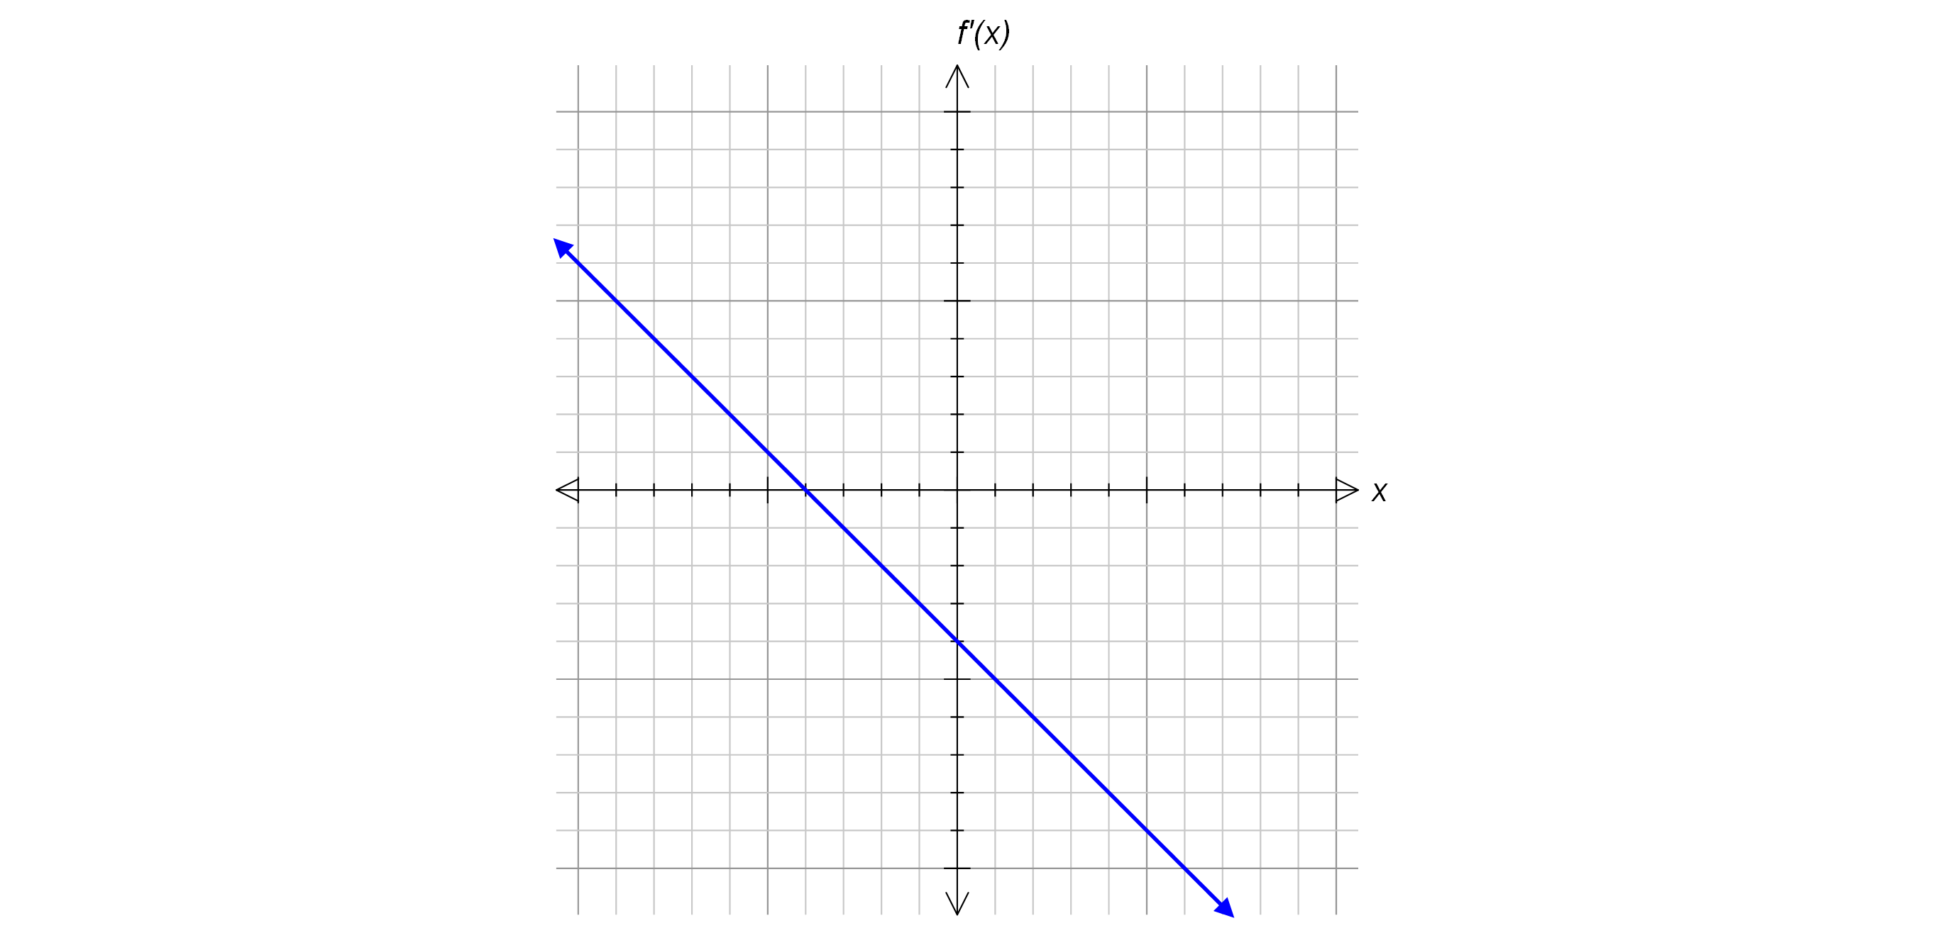  x intercept aligns with turning point |  |  |  | Correct
(b)(i) | h' (x) = 2x – 12 = 4  x = 8 |  |  |  | Correct x  co-ordinate found.
(ii) | h' (1) = 2 – 12 = –10  y + 11 = –10(x – 1)  y = –10x – 1 |  |  |  | Gradient found. |  |  | Equation correct.
(c) | g' (x) = 3x² – 18x + 24  x² – 6x + 8 = 0  2 < x < 4  Justification:  Shape of cubic OR  check gradient at a point. |  |  |  | Derivative found and set equal to 0. |  |  | Solution without justification. |  | Justified solution.
(d) | 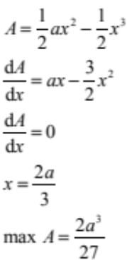 |  |  |  |  |  |  | Derivative found. |  | x found.
NØ |  | N1 | N2 | A3 |  | A4 | M5 |  | M6 | E7 | E8
No response; no relevant evidence |  | Attempt at one question | 1 of u | 2 of u |  | 3 of u | 1 of r |  | 2 of r | 1 of t | 2 of t

Q | Evidence |  |  |  | Achievement (u) |  | Merit (r) |  |  | Excellence (t)
THREE  (a) | f(x) = 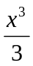– x²  f(6) = 72 – 36  Hence (6,36) |  |  |  | Anti-differentiation found. |  | Coordinates found.
(b) | 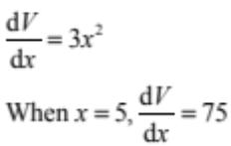 |  |  |  | Rate of change of volume found.
(c) | Positive cubic drawn with minimum on x-axis.  Minimum at (a , 0) and maximum aligned to  x-intercept on h'(x)  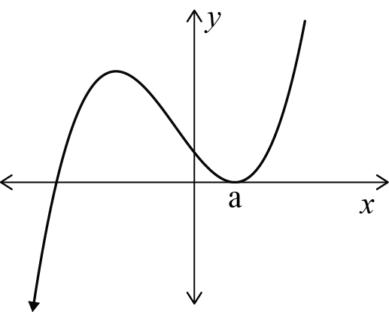 |  |  |  | Positive cubic drawn. |  | Cubic drawn with min at (a,0) and max aligned with  x-intercept.
(d) | f ' (x) = 6x² + A  f ' (–2) = 6 × 4 + A = 10  A = –14  33 = 2 × –8 – 14 × –2 + B  B = 21  f (x) = 2x³ – 14x + 21  f (4) = 93  Hence (4, 93) |  |  |  | f ' (x) found and set equal to 10. |  | B found. |  |  | Coordinates found.
(e) | A =(1+2t )²  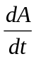= 2 + 4t  = 60  t = 4.27  Width = 9.55 m |  |  |  | Derivative found. |  | A ' = 60 |  |  | Width found.
NØ |  | N1 | N2 | A3 | A4 | M5 |  | M6 | E7 |  | E8
No response; no relevant evidence |  | Attempt at one question | 1 of u | 2 of u | 3 of u | 1 of r |  | 2 of r | 1 of t |  | 2 of t

Judgement Statement
 | Not Achieved | Achievement | Achievement  with Merit | Achievement  with Excellence
Score range | 0 – 7 | 8 – 14 | 15 – 20 | 21 – 24

